**PCB WORKSHOP**

CIRCUIT DESIGNING AND IMPLEMENTATION WORKSHOP

# 

**REPORTED BY : TEAM LLM**

**GROUP DETAILS:**

1. Maruthi M
2. Lakshman B H
3. K Lokeshwar Reddy

REPORTED ON: 25/05/2024



## SIMULATION RESULTS:

1. AUDIO AMPLIFIER

**SCHEMATIC DIAGRAM**

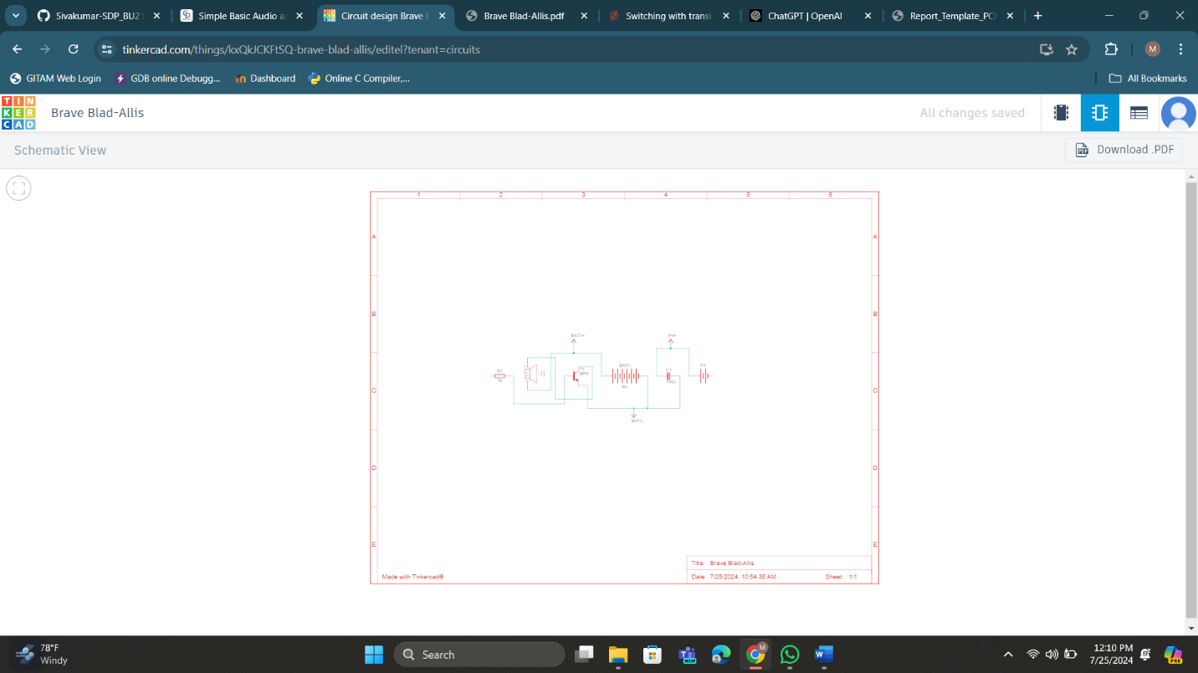

**COMPONENTS**

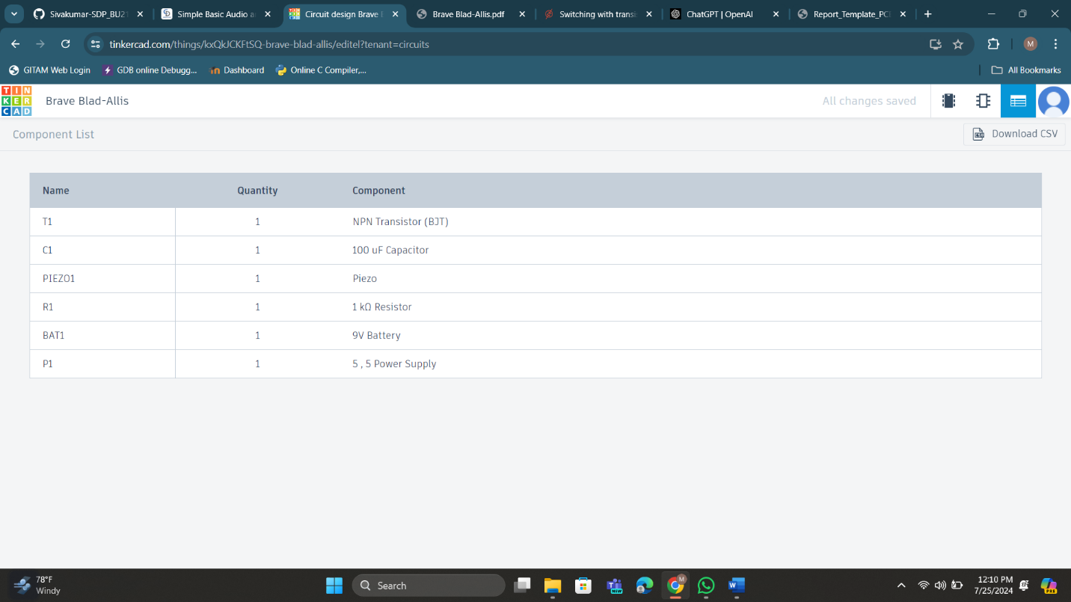

**Connections**:

* **Base Resistor**: Connect a 10kΩ resistor between the microphone output and the base of the transistor.
* **Collector Resistor**: Connect a 1kΩ resistor between the collector of the transistor and the positive rail.
* **Emitter**: Connect the emitter directly to the ground.
* **Coupling Capacitors**: Use a 10µF capacitor to connect the microphone to the base resistor and another 10µF capacitor to connect the collector to the speaker.
* **Power Supply**: Connect the 9V supply between the positive rail and ground.

(B)**TINKERCAD SIMULATION RESULT:**

**CIRCUIT LAYOUT**

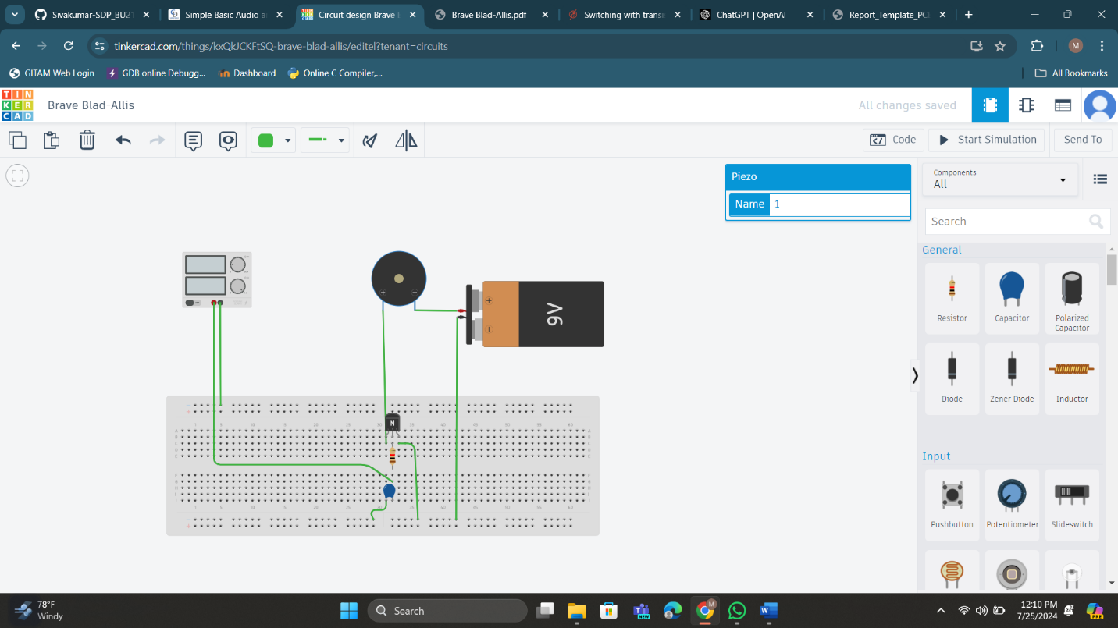

EASYEDA CIRCUIT DIAGRAM:

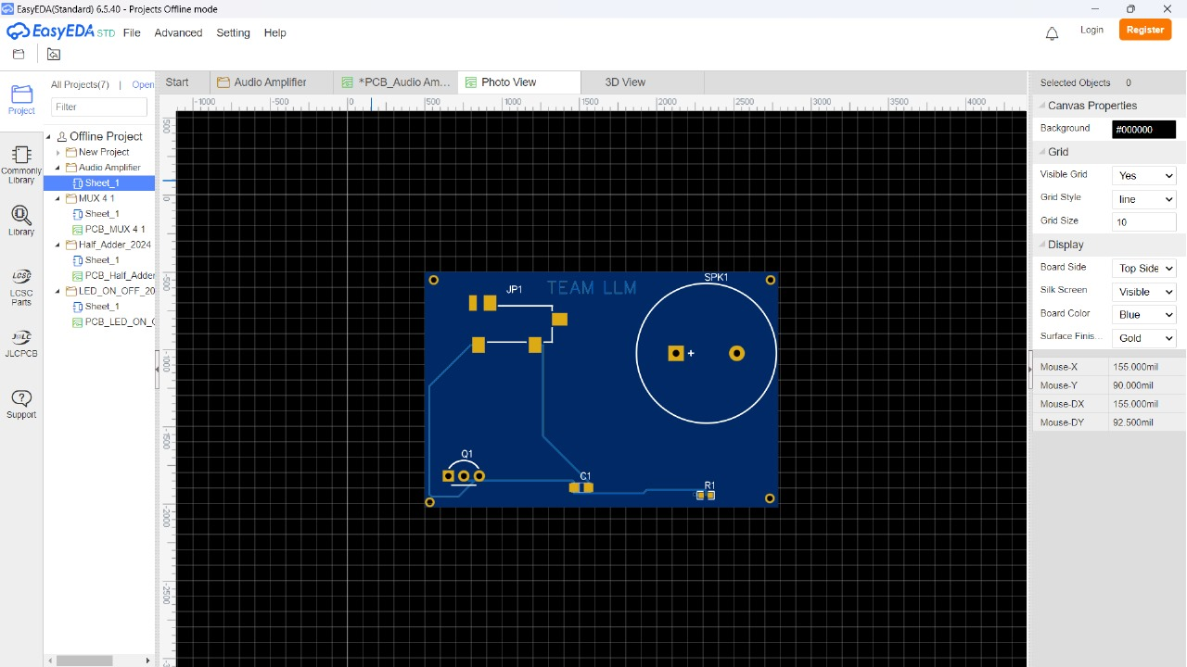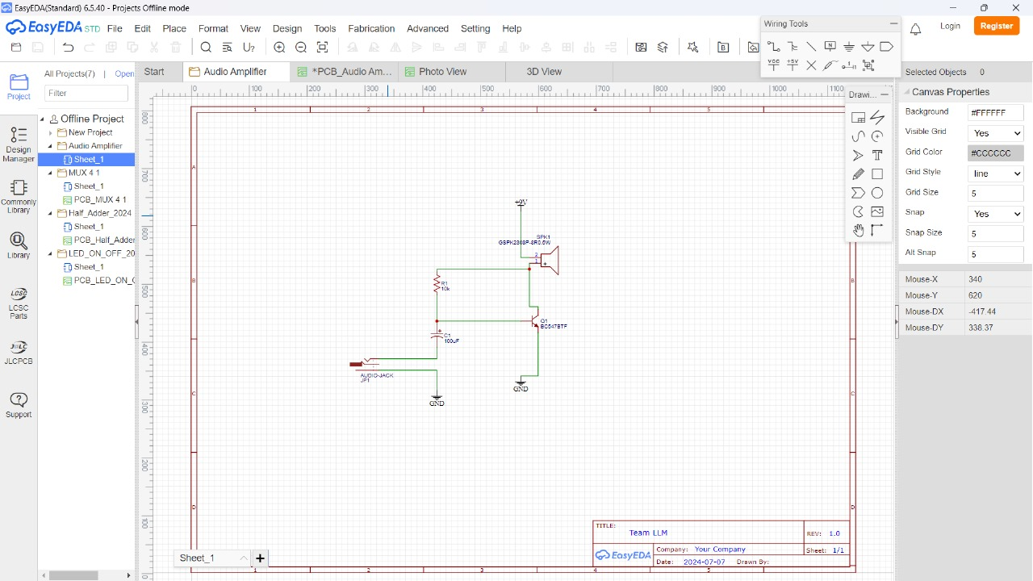2D Diagram:

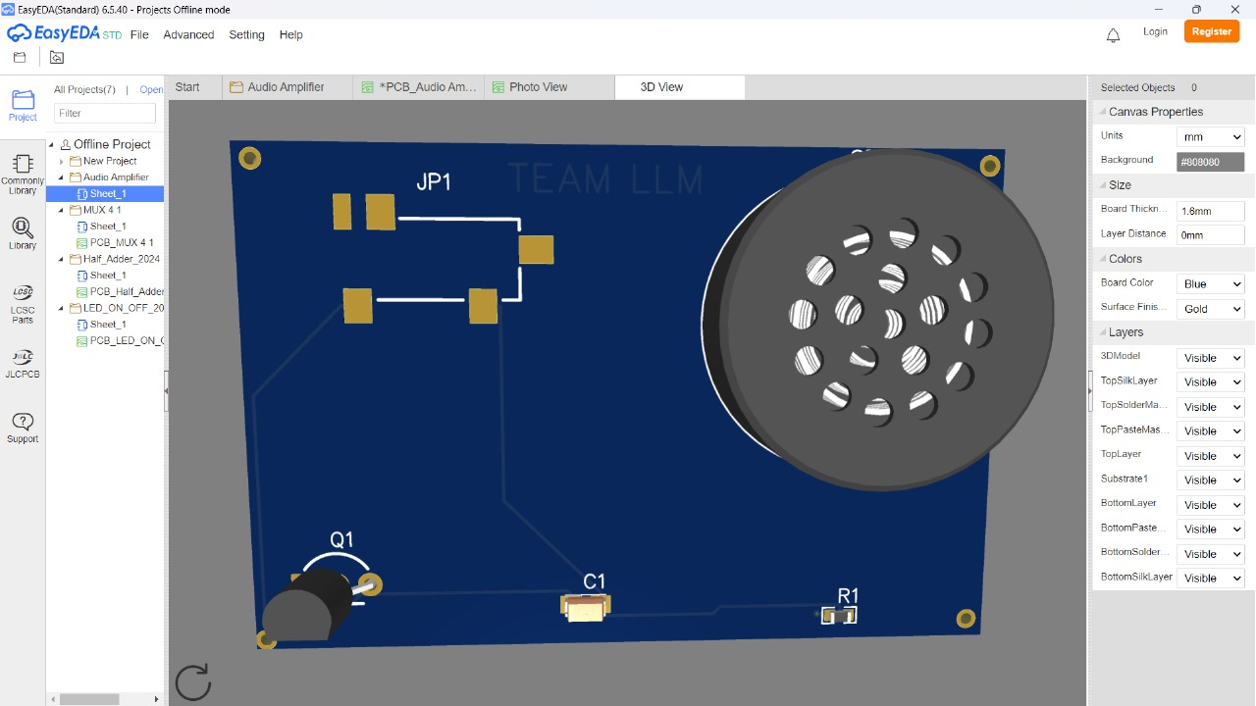3D Diagram: